# **Synopsis**

# **On**

**Tours and Travel Management System**

Submitted by:-

Prapti Madhur

ABMCS15011

M.sc(CS)IV sem

**Introduction:**

The Tours and Travel Management System is a web based application. The purpose of “Tours and Travel management system” is to develop a system that automates the processes and activities of a travel agency.There is a tour and travel agency who is planning to become a market leader by automating its human travel agents and organization with an automated tour and travel system for processing flight reservations, booking hotels, booking vehicles and trains and holiday packages. This automated travelling system will intermediate between travelers and the computing system, which interfaces with commercial hotel package booking, reservation services in flights as well as train. Like a human travel agent, it will assist travelers in booking, changing, and canceling flight reservations.

**Objectives:**

* Main objective of this system is to provide Tour package information, Ticket booking, Online Registration, Online payment and searching facility for customer.

This application is develop to provide best travelling services to the customer and tracel agents.”Tours and travel management system” is developed to provide a search platform where tourists can find their tour places according to their choices and it also helps to promote responsible and interesting tourism so that people can enjoy their holidays at their favorable places.

**Existing System (Problem Statement):**

In the present system a customer has to approach various agencies to

find details of places and to book tickets. This often requires a lot of time and effort. A customer may not get the desired information from these offices and often the customer may be misguided. It is tedious for a customer to plan a particular journey and have it executed properly.

**Proposed System:**

Automated travelling system will process a wide range of flight, train reservation service requests, holiday packages and transactional issues. These include, but are not limited to:

* inquiring about flights and airfares,
* making, changing, and canceling traveler profiles and accounts,
* booking, changing, confirming, and canceling flight as well as train reservations,
* generating travel itineraries.

**An Example of a Simple Service Request Transaction:**

A user with a valid system account and a valid travel account logs in to the system, requests to book a holiday package, select locations, flight reservation, selects a flight, selects a payment method, and specifies delivery services for the flight and train tickets and travel itineraries. The system will accommodate both individual and corporate traveler accounts for domestic travel requests only.

**System Requirements:**

The tour and travel system must be capable of providing fast, accurate, and courteous ("user friendly") services for all requests supported. The system must be able to:

* answer inquiries about flights and fares,
* generate, modify, and cancel traveler profiles and travel accounts,
* make, change, complete, and cancel reservations,
* obtain payment method and verify traveler credit line,
* generate travel itineraries and arrange for delivery of flight tickets and flight itineraries.

Types of ticket delivery services include mail, courier, and airport pick-up,

Types of itinerary delivery services include mail, fax, e-mail.

**Software Requirements:**

Front end: Java/J2EE technologies (Servlet, JSP), HTML, CSS, JS, JDBC

Back end: Oracle Database 10g Express Edition.

Middleware/Server: Apache Tomcat v7.0.

IDE: Eclipse IDE for Java EE Developers

Browser: Best result on Mozilla Firefox

Operating System: Window XP (Minimum).

**Hardware Requirements:**

CPU: Pentium 4.

RAM: 256 MB.

Space on HD: 5 MB.

Display: CRT, LCD.

# DATA FLOW DIAGRAMS

The Data flow Diagram shows the flow of data. DFD is an important tool used by system analysts. The main merit of DFD is that it can provide an overview of what data a system would process, what transformations of data are done, what files are used, and where the results flow. The graphical representation of the systems makes it a good communication tool between a user and analyst. DFDs are structured in such a way that starting from a simple diagram which provides a broad overview at a glance, they can be expanded to a hierarchy of diagrams giving more and more details.

It is generally made of symbols given below:

(1) A **square** shows the Entity: -

(2) A **Circle** shows the Process: -

(3) An **open Ended Rectangle** shows the data store: --

(4) An **arrow** shows the data flow

* **Level 0 DFD:**

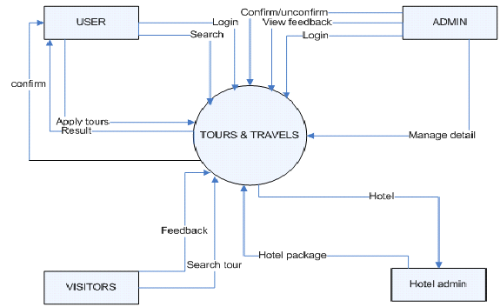

* **DFD Level 1 (Admin Side):**

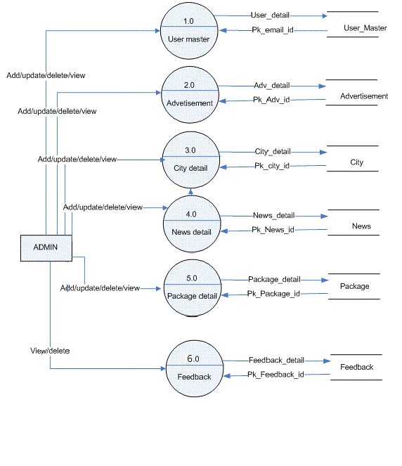

* **DFD Level 1 (Tour Side):**

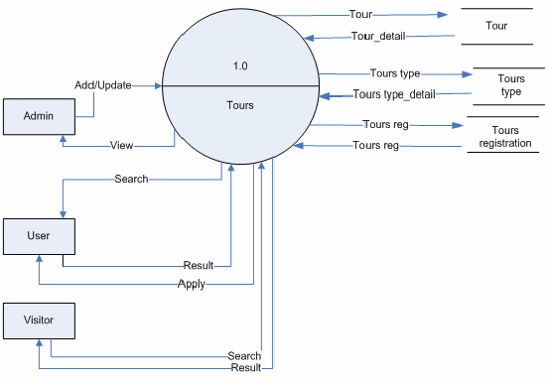

**DFD Level 1 (Visitor Side):**

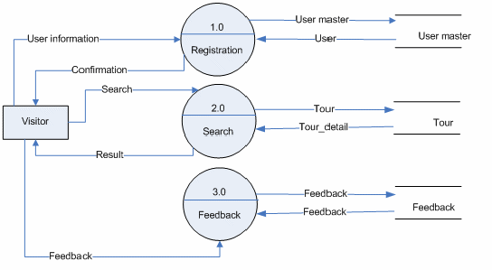

* **DFD Level 1 (User Side):**

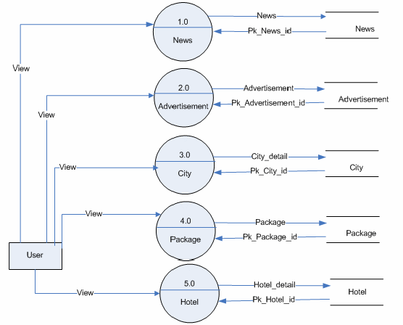

# ENTITY RELATIONSHIP

# DIAGRAM

# (ERD)

**Definition:**

An entity-relationship (ER) diagram is a specialized graphic that illustrates the interrelationships between entities in a database. ER diagrams often use symbols to represent three different types of information. Boxes are commonly used to represent entities. Diamonds are normally used to represent relationships and ovals are used to represent attributes.

**Entity Relationship (ER) diagrams:**

This diagramming technique is used to visually present a database schema or data model and was original proposed by Chen in the 1970s. There are many different data modeling notations; some are very similar to UML class diagrams (with the exception of operations). However, the notation the used here is slightly different, as proposed by Elmasri, et al.

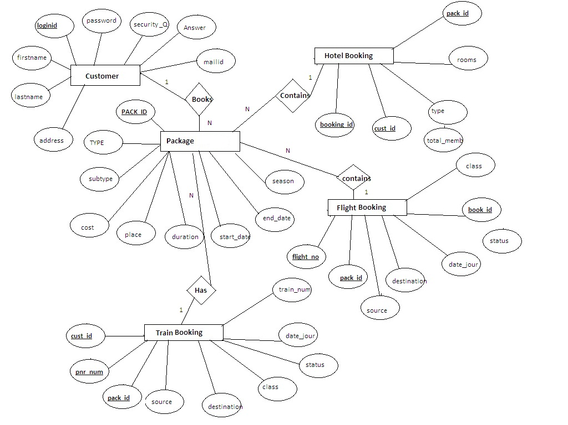

**Data Dictionary:**

**Table name: CUSTOMER**

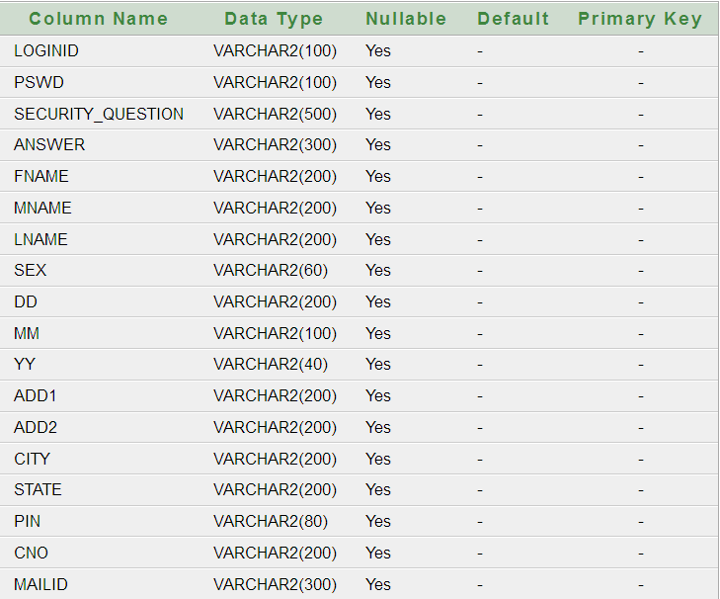

**Table: FLIGHTBOOKING**

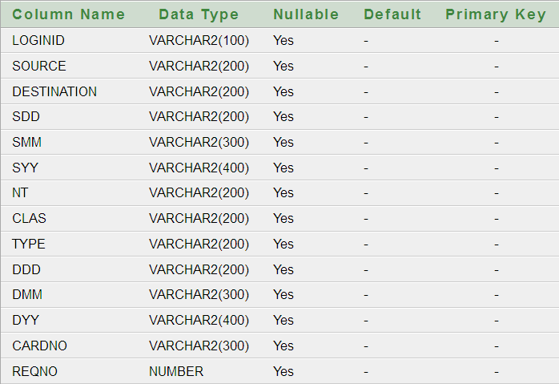

**Table: CARBOOKING**

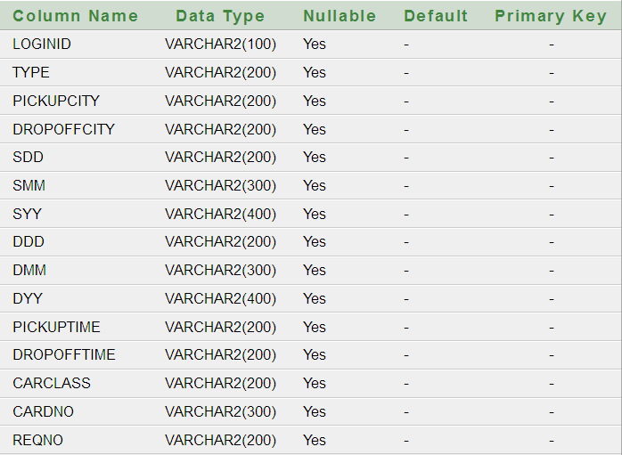

**CRUISE BOOKING**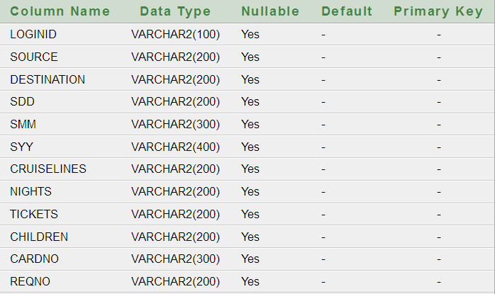

**HOTELBOOKING**

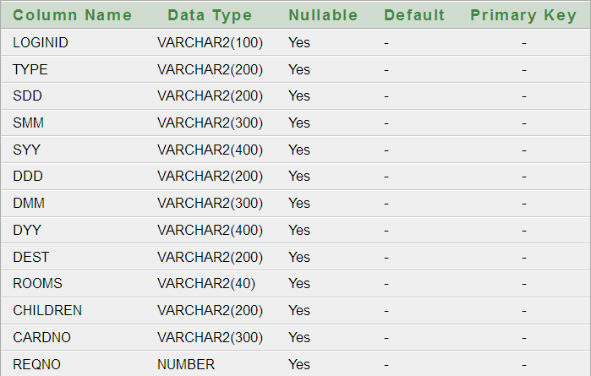

**HOTELBOOKING**



**Future Scope:**

While at first the system will specialize in agent based booking, in the future it is expected to be able to:

* Make hotel and rental car reservations.
* Issue "ticketless" reservations. For example, "ticketless" flight reservations will work as follows: travel agents making flight reservations will issue travelers confirmation numbers (and not a ticket). At the airline gate the traveler will show photo identification and the gate agent will locate the flight reservation and issue a boarding pass.
* Easy payment methods (By credit card or Net banking or even Cash on Delivery).
* So now this website is going to be a free services website.
* This service gives more discount at a time of a current online booking.